**Project Design Phase-II**

**Data Flow Diagram & User Stories**

|  |  |
| --- | --- |
| Date | 17 June 2025 |
| Team ID | LTVIP2025TMID60014 |
| Project Name | Health AI-Intelligent Healthcare Assistant using IBM Granite |
| Maximum Marks | 4 Marks |

**Data Flow Diagrams:**

A Data Flow Diagram (DFD) in health care visually represents how a patient data moves through a system, showing the flow of information between entities like patients, doctors, and administrators, and how it’s processed, stored and used. DFDs are crucial for understanding and optimizing healthcare processes, improving data accuracy and enhancing patient care.

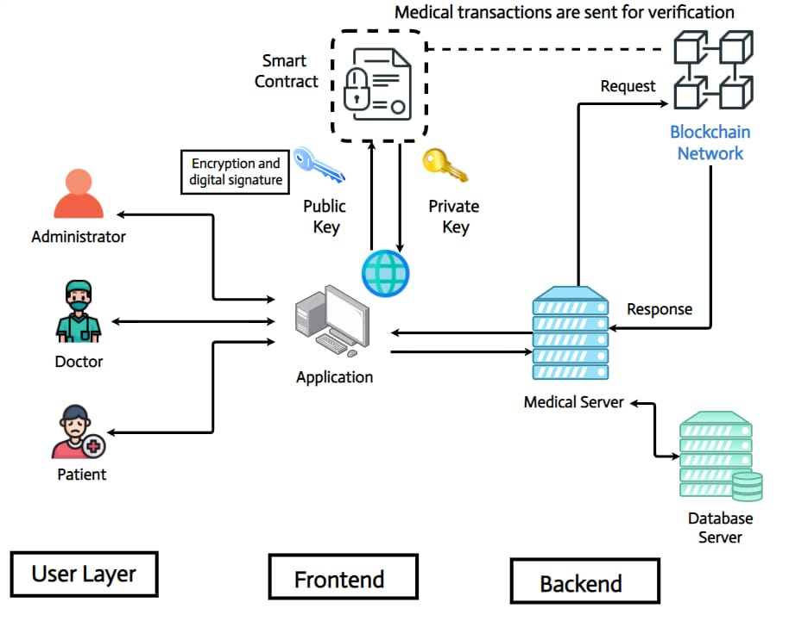

**Example:**

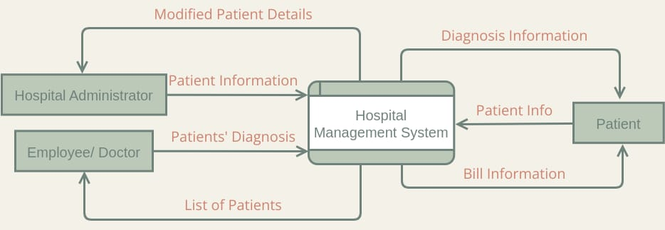

**User stories:**

Use the below template to list all the user stories for the product.

| **User Type** | **Functional Requirement (Epic)** | **User Story Number** | **User Story / Task** | **Acceptance criteria** | **Priority** | **Release** |
| --- | --- | --- | --- | --- | --- | --- |
| Customer (Mobile user) | Registration | USN-1 | As a user, I can register for the application by entering my email, password, and confirming my password. | I can access my account / dashboard | High | Sprint-1 |
| Customer (Mobile user) | Registration | USN-2 | As a user, I will receive confirmation email once I have registered for the application | I can receive confirmation email & click confirm | High | Sprint-1 |
| Customer (Mobile user) | Registration | USN-3 | As a user, I can register for the application through Facebook | I can register & access the dashboard with Facebook Login | Low | Sprint-2 |
| Customer (Mobile user) | Registration | USN-4 | As a user, I can register for the application through Gmail | I can register and access dashboard using Gmail | Medium | Sprint-1 |
| Customer (Mobile user) | Login | USN-5 | As a user, I can log into the application by entering email & password | Login is successful and redirects to dashboard | High | Sprint-1 |
| Customer (Mobile user) | Doctor connect | USN-6 | As a user, I can escalate to a doctor if AI response is not satisfactory | I can request a human consultation | Medium | Sprint-3 |
| Customer (Web user) | Dashboard access | USN-7 | As a user, I can use web interface to interact with the assistant | Responsive and accessible web interface | High | Sprint-1 |
| Customer (Web user) | Notifications | USN-8 | As a user, I can receive appointment and medication remainders | Remainders are timely and accurate | Medium | Sprint-2 |
| Customer Care Executive | Query support | USN-9 | As a support executive, I can view un resolved user issues | Issues are clearly displayed in the dashboard | Medium | Sprint-2 |
| Customer Care Executive | Escalation handling | USN-10 | As a support executive, I can escalate cases to doctors | Escalation workflow is functional | Medium | Sprint-3 |
| Administrator | User management | USN-11 | As an admin, I can manage roles and permissions of users | Role-based access works correctly | High | Sprint-1 |
| Administrator | System monitoring | USN-12 | As an admin, I can monitor system activity and AI usage | Logs are accurate and timely | High | Sprint-1 |